
Department of Computer Science and Applications
----------------------------------------------------------------------------------------------------
Mini Project on Full Stack Development
ShopNest- An Ecommerce Website
FYMCA
Division – C
A.Y 2025-2026
Group Name: CodeNest Mate
----------------------------------------------------------------------------------------------------
Mentors
Raja Bavani Kaustubh Keer
----------------------------------------------------------------------------------------------------
Project Members
Sr. No. | Name | PRN No. | Mobile No.
1 | Pranoti Varpe | 1272240903 | 7666135487
2 | Shivam Tamboli | 1272240604 | 6263166799

TABLE OF CONTENT

Sr. No | Topic | Page No.
1. | Problem Statement | 3
2. | Project Scope | 4
3. | Project Objective | 5
4. | Flow Of The System | 6
5. | Master Use-case Diagram | 7
6. | Use-case Diagram | 8
7. | Sequence Diagram | 11
8. | Class Diagram | 12
9. | Module Description | 13
10. | Hardware And Software Details | 14
11. | Limitation | 15
12. | Feasibility Study | 16
13. | Working module Screenshots | 17
14. | Future Scope | 18
15. | Conclusion | 19
16 | Team Member Sign | 20

PROBLEM STATEMENT

In today’s fast-paced digital world, customers expect a smooth, personalized, and secure online shopping experience. However, many small and medium businesses face challenges in building and maintaining an effective eCommerce platform due to technical complexity, high costs, and lack of customization options.
Existing online stores often suffer from poor user interface design, slow performance, and inefficient product management systems, leading to reduced customer satisfaction and engagement. Additionally, security concerns during transactions and weak authentication mechanisms further discourage users from trusting such platforms.
ShopNest aims to address these challenges by developing a modern, responsive, and user-friendly eCommerce website that provides a seamless experience for both customers and administrators. The system focuses on efficient product display, secure authentication, smooth navigation, and easy backend management, enabling businesses to establish a strong online presence with minimal effort and cost.

PROJECT SCOPE

The ShopNest project aims to design and develop a comprehensive eCommerce web application that enables users to browse, search, and purchase products seamlessly while providing administrators with efficient tools for managing inventory, users, and orders.
The system will feature secure user authentication, dynamic product management, shopping cart functionality, and responsive UI design to ensure accessibility across devices. The backend will handle database operations such as product insertion, updates, deletions, and order tracking, ensuring smooth and reliable functionality.
The scope also includes implementing search and filter options, a wishlist system, and basic order analytics to enhance user engagement and admin decision-making. Additionally, the project emphasizes security, performance optimization, and user experience, making it suitable for small to medium-sized businesses aiming to establish their online presence.
However, the project does not cover integration with external payment gateways or logistics APIs in its current phase. Future enhancements may include AI-based product recommendations, real-time order tracking, and advanced analytics dashboards.
In summary, ShopNest will serve as a scalable, secure, and user-friendly eCommerce solution that bridges the gap between business needs and customer expectations.

PROJECT OBJECTIVE

The primary objective of ShopNest is to develop a modern, secure, and user-friendly eCommerce web application that simplifies online shopping and enhances the buying experience for users while providing an efficient management interface for administrators.

Specific Objectives:
- To design a responsive and visually appealing interface using modern web technologies, ensuring smooth navigation across all devices.
- To implement secure user authentication and authorization systems for both customers and administrators.
- To enable dynamic product management — allowing admins to add, edit, delete, and view products efficiently.
- To integrate a functional shopping cart system that allows users to add, remove, and review items before checkout.
- To build a well-structured backend with database connectivity for handling product details, user data, and transactions.
- To ensure data integrity, scalability, and performance optimization through efficient coding practices and structured queries.
- To provide a smooth and engaging user experience that encourages trust, ease of use, and customer satisfaction.

FLOW OF THE SYSTEM

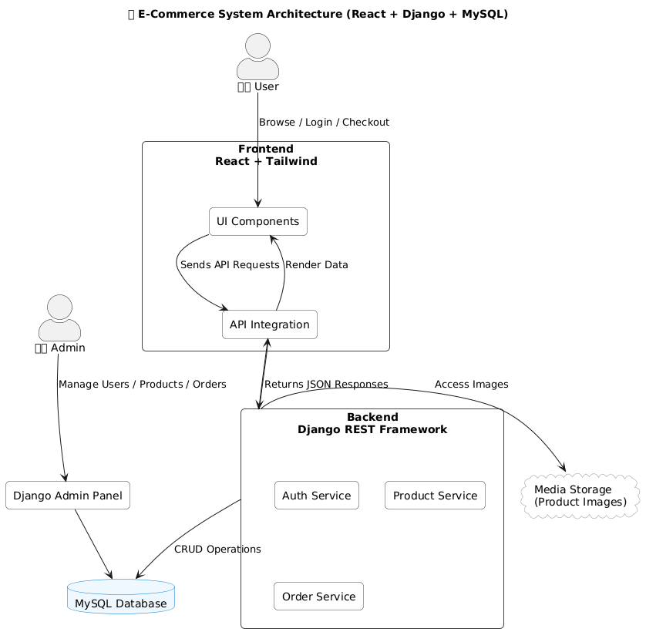

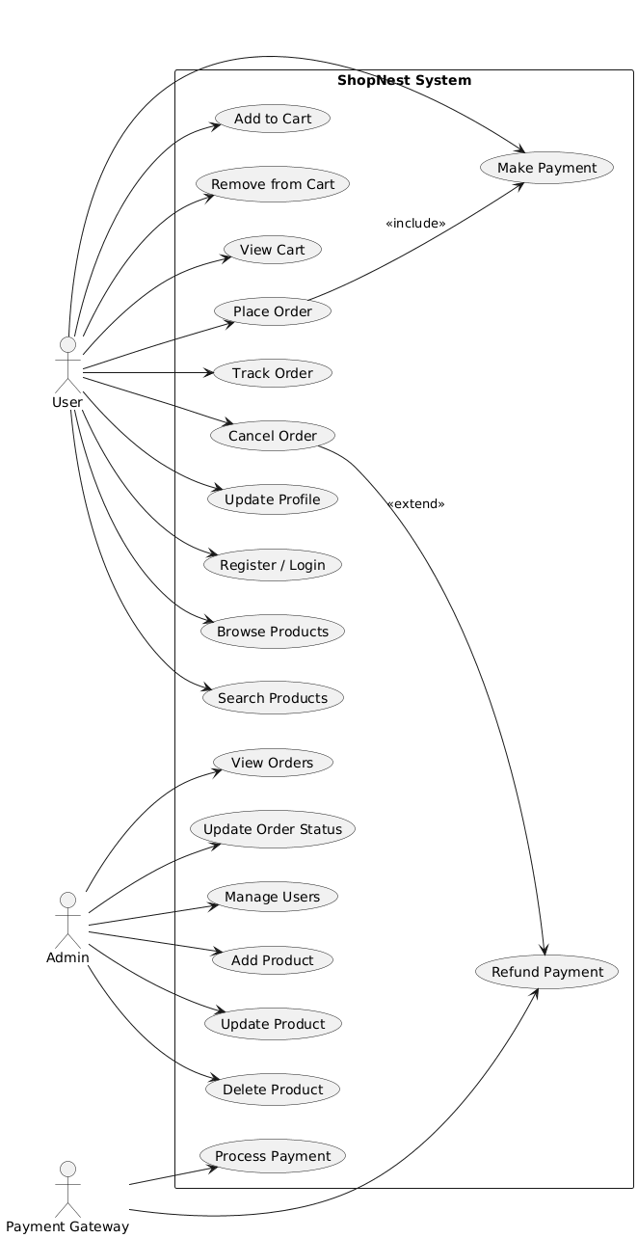
MASTER USE-CASE DIAGRAM

USE-CASE DIAGRAM

- User Module Actor: Customer
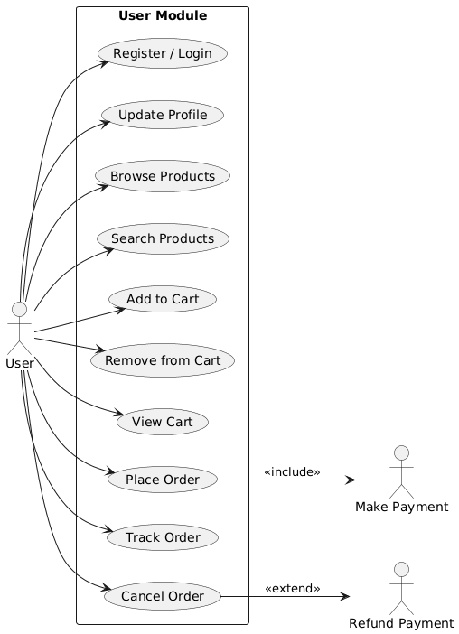

- Product Module Actor: Customer
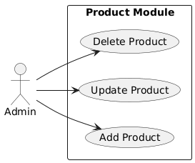

- Order Module Actor: Admin

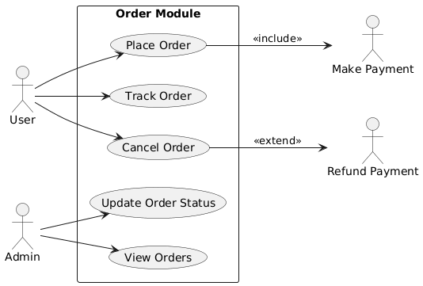

- Payment Module Actor: Customer

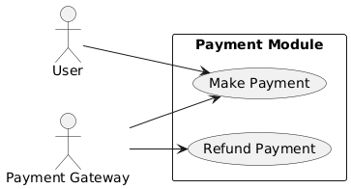

- Admin Module Actor: Admin

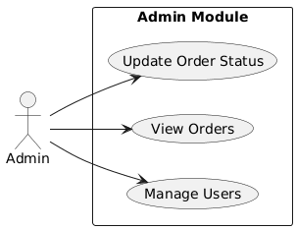


SEQUENCE DIAGRAM

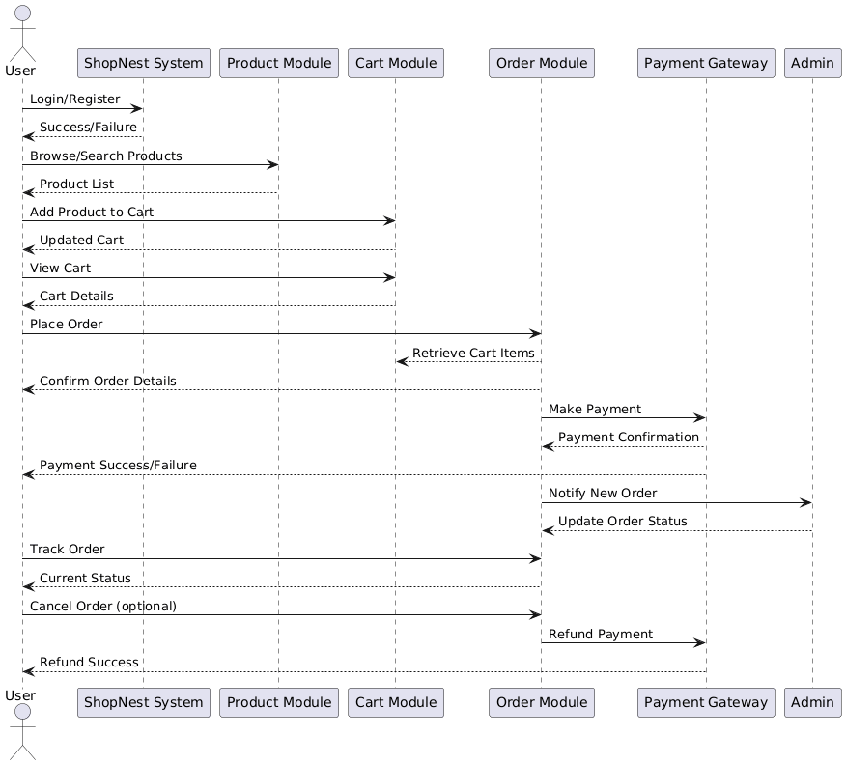

CLASS DIAGRAM

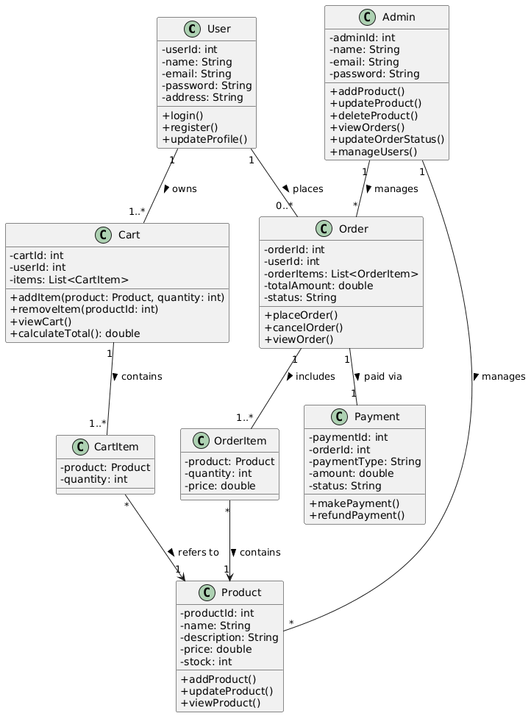

MODULE DESCRIPTION

HARDWARE AND SOFTWARE DETAILS

- Hardware Requirements:
• Processor: Intel i3 or equivalent (recommended Intel i5/i7 or AMD Ryzen 5+)
• RAM: 4 GB minimum (recommended 8 GB or higher)
• Hard Disk: 256 GB minimum (recommended 512 GB SSD or higher)
• Display: 1024 x 768 resolution (recommended 1920 x 1080)
• Network: Internet connection (recommended high-speed broadband)

- Software Requirements:
• Operating System: Windows 10/11, Linux, or macOS
• Backend: Java Spring Boot (latest stable version)
• Frontend: React JS (latest stable version)
• Database: MySQL (version 8.0 or higher)
• IDE / Editor: VS Code
• Browser: Google Chrome or Firefox
• Version Control: Git (GitHub or GitLab repository)
• Node.js & npm (required for React development)
LIMITATION

- Limited Order Management – The system supports only basic order placement and tracking; advanced logistics or shipment modules are not implemented.

- Email or SMS Notifications Not Implemented – Automated alerts for order confirmation, password reset, or delivery updates are not included
.
- Restricted Admin Analytics – The admin dashboard provides limited reporting and lacks detailed sales or performance analytics.

FEASIBILITY STUDY

- Technical Feasibility:
Shopnest uses widely available, open-source technologies such as React.js, Node.js, and MongoDB, making it easy to build and deploy. The integration of AI modules adds to its learning value without requiring heavy infrastructure.

- Economic Feasibility:
The project is cost-effective since it uses free-tier hosting services, open-source libraries, and cloud-based databases.

- Operational Feasibility:
The platform is user-friendly and designed for both beginners and academic demonstrations. Admins can easily manage users and stocks.

- Educational Feasibility:
The system is highly suitable for academic use. It helps students understand trading workflows, market simulations, and AI applications in finance.

WORKING MODULE SCREENSHOTS

FUTURE SCOPE

The ShopNest eCommerce platform lays a solid foundation for online retail but also offers significant potential for future enhancements and expansion. The project can be scaled and improved in several ways:
- Advanced Search and Recommendation Systems – Incorporating AI-driven product recommendations, personalized offers, and predictive search can enhance user engagement and sales.
- Mobile Application Development – A dedicated ShopNest mobile app for Android and iOS can expand reach and improve accessibility for customers on the go.
- Order Tracking and Logistics Integration – Real-time order tracking, shipment notifications, and integration with delivery services can further streamline the shopping experience.
- Analytics and Reporting – Advanced sales analytics, customer insights, and inventory forecasting dashboards can help administrators make data-driven business decisions.
- Multi-Vendor Support – In the future, ShopNest can evolve into a marketplace platform, allowing multiple sellers to register, list products, and manage orders independently.
- Enhanced Security Measures – Implementation of two-factor authentication, encryption protocols, and fraud detection mechanisms can strengthen user trust.

CONCLUSION

The ShopNest project successfully demonstrates the development of a full-stack e-commerce application that integrates all essential features for both users and administrators. The system provides a seamless shopping experience, including user registration, product browsing, cart management, order placement, and secure payment processing. The admin module ensures efficient management of products, orders, and users, while the modular design of the system promotes scalability and maintainability. Overall, ShopNest highlights the practical implementation of modern web technologies to build a robust, user-friendly, and secure online shopping platform, serving as a comprehensive solution for e-commerce management.

TEAM MEMBER SIGN

